

Practical Project
Assistive Disability Interaction System
By
Nada Mohamed Zainelaabdin Cs
Manar Abdelbaky Hassan Ai
Sara Mahmoud Abdelrahman Cs

Supervised by:
Dr. Ayman Hassanein
Co-Supervisor:
Eng. Mohamed Amer
Eng. Ahmed Abdelmonem

Egypt 2025

Table of Contents

Table of Contents

Table of Figures

Table of Figures

Abstract

Chapter One
"Introduction"

Chapter One
Introduction

Chapter Two
"Design and Methodology"

Chapter Two
Design and Methodology
2.1 Requirements and Analysis
2.1.1 User requirements

2.1.2 Software requirements
2.1.2.1 Functional requirements

2.1.2.2 Non-functional requirements

2.1.1 Software Process Model:
The system design model that we use is Incremental model according to system needs and our team suggestions
2.1.1 What is Incremental Model?
The Incremental Model is a software development approach where the system is built and delivered
in small, functional parts called increments. Each increment adds more features to the system until
the complete system is delivered. Early increments may contain core functionality, and subsequent
increments enhance the system with additional features.
2.1.2 Phases of Incremental Model
- Requirement
- Design
- Testing phases
- Implementation phase

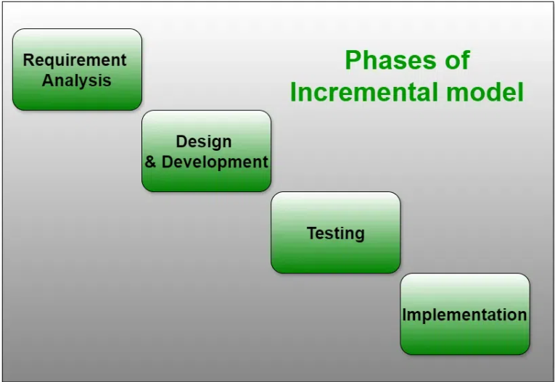
2.1.3 Advantages of Incremental Model
- Early delivery of core functionality allows users to start using the system sooner
- It is easier to manage risk and make changes in later increments.
- Allows feedback from users after each increment to improve subsequent parts.
2.1.4 Disadvantages of Incremental Model
- Incomplete systems in early increments may not provide full functionality to users.
- Requires careful planning to ensure all increments integrate smoothly.
- Can become costly if initial design is not flexible enough for changes.
2.2 System Models
2.2.1 Interaction perspective
2.2.1.1 Use Case Diagram

2.2.1.2 Sequence Diagram

2.2.2 Data Flow Diagram
2.2.2.1 Context Diagram

2.2.2.2 DFD (Level 1)

2.2.2.3 DFD (Level 2)

2.2.3 Activity Diagram

2.2.4 Structural perspective
2.2.4.1 Class Diagram

2.2.5 Entity Relationship Diagram (ERD)

References

References

